NIST INSTRUCTOR’S MANUAL
Table of Contents
INTRODUCTION 1
Lesson Plan: POSITION (MAN/PAY 1) 2
Introduction: 2
Pre-Flight Briefing: 2
Simulating BVLOS: 3
Lesson Plan: TRAVERSE (MAN/PAY 2) 4
Introduction: 4
Pre-Flight Briefing: 4
Simulating BVLOS: 5
Lesson Plan: ORBIT (MAN/PAY 3) 6
Introduction: 6
Pre-Flight Briefing: 6
Simulating BVLOS: 7
Lesson Plan: INSPECT (MAN/PAY 4) 8
Introduction: 8
Pre-Flight Briefing: 8
Simulating BVLOS: 9
Lesson Plan: RECON (MAN/PAY 5) 10
Introduction: 10
Pre-Flight Briefing: 10

INTRODUCTION
The NIST Standard Test Methods for Small Unmanned Aircraft Systems (sUAS) are a comprehensive set of standardized procedures developed by the National Institute of Standards and Technology. These methods aim to evaluate and compare the performance of small drones and assess the proficiency of their pilots. The test methods cover various critical aspects such as maneuverability, payload functionality, and visual acuity. Designed to be cost-effective and easy to implement, these tests provide a uniform framework that can be used across different organizations, making them highly accessible and practical for educational settings, such as community colleges​ (NIST).
For student pilots, these standardized test methods offer an excellent opportunity to introduce the practical and theoretical aspects of drone operation. By incorporating these methods into the curriculum, instructors can provide students with hands-on experience in performing standardized tests that mimic real-world scenarios. This not only enhances the learning experience but also prepares students for industry-standard evaluations. The tests are particularly beneficial for training students in public safety and emergency response roles, where drone proficiency can significantly impact mission success. By using these methods, instructors can objectively measure and improve their students' piloting skills, ensuring they meet the rigorous demands of professional sUAS operations (NIST) (NIST).

Lesson Plan: POSITION (MAN/PAY 1)
Introduction:
In this lesson, students will learn to perform basic flight maneuvers and alignments. The objective is to evaluate the pilot's ability to control the drone’s position, orientation, and altitude precisely. This foundational skill is crucial for safe and efficient drone operations, ensuring the pilot can maintain control in various scenarios.

Pre-Flight Briefing:
Objectives: Successfully perform a series of maneuvers between designated hover positions along the lane centerline.
  - Demonstrate basic flight maneuvers between designated hover positions, orientations, and altitudes along the lane centerline at altitudes S and 2(S). (S=Altitude and is also the distance between bucket stands. If buckets are spaced 10 feet apart then your maximum altitude should be 10 ft AGL)
  - Climb, descend, yaw, pitch, and roll to simultaneously TAKE A PICTURE OF downward buckets to check position then forward buckets to check altitude.
  - Complete 10 positions along the lane centerline with 18 alignments and 1 accurate landing (counts double) to score up to 100 points.
Safety Check: Ensure all safety protocols are followed, including pre-flight inspection of the drone and surrounding area.
Equipment: Ensure the drone is fully functional and the camera settings are adjusted for optimal image capture.
Procedure:
POSITION TEST – FLYING ALONG CENTERLINE
- LAUNCH AND HOVER OVER STAND #1 TAKE A PICTURE OF BUCKET 1&BUCKET 2A
- YAW LEFTWARD 360° OVER STAND #1 TAKE A PICTURE OF BUCKET 1&BUCKET 2A
- YAW RIGHTWARD 360° OVER STAND #1 TAKE A PICTURE OF BUCKET 1&BUCKET 2A
- CLIMB VERTICALLY (2XS) OVER STAND #1 TAKE A PICTURE OF BUCKET 1&BUCKET 3A
- DESCEND VERTICALLY OVER STAND #1 TAKE A PICTURE OF BUCKET 1&BUCKET 2A
- PITCH FORWARD OVER STAND #2 TAKE A PICTURE OF BUCKET 2&BUCKET 3A
- PITCH BACKWARD OVER STAND #1 TAKE A PICTURE OF BUCKET 1&BUCKET 2A
- PITCH FORWARD OVER STAND #2 THEN YAW LEFT 180° TAKE A PICTURE OF BUCKET 2&BUCKET 1C
- PITCH FORWARD OVER LANDING THEN YAW RIGHT 180° TAKE A PICTURE OF LANDING PAD&BUCKET 1A
- LAND IN CIRCLE (ONE OR MORE LEGS ) – WORTH 2 POINTS
https://drive.google.com/file/d/1g1_kkFJW6wfsD68V_9NXUiOR3Mu8I9ly/view?usp=sharing

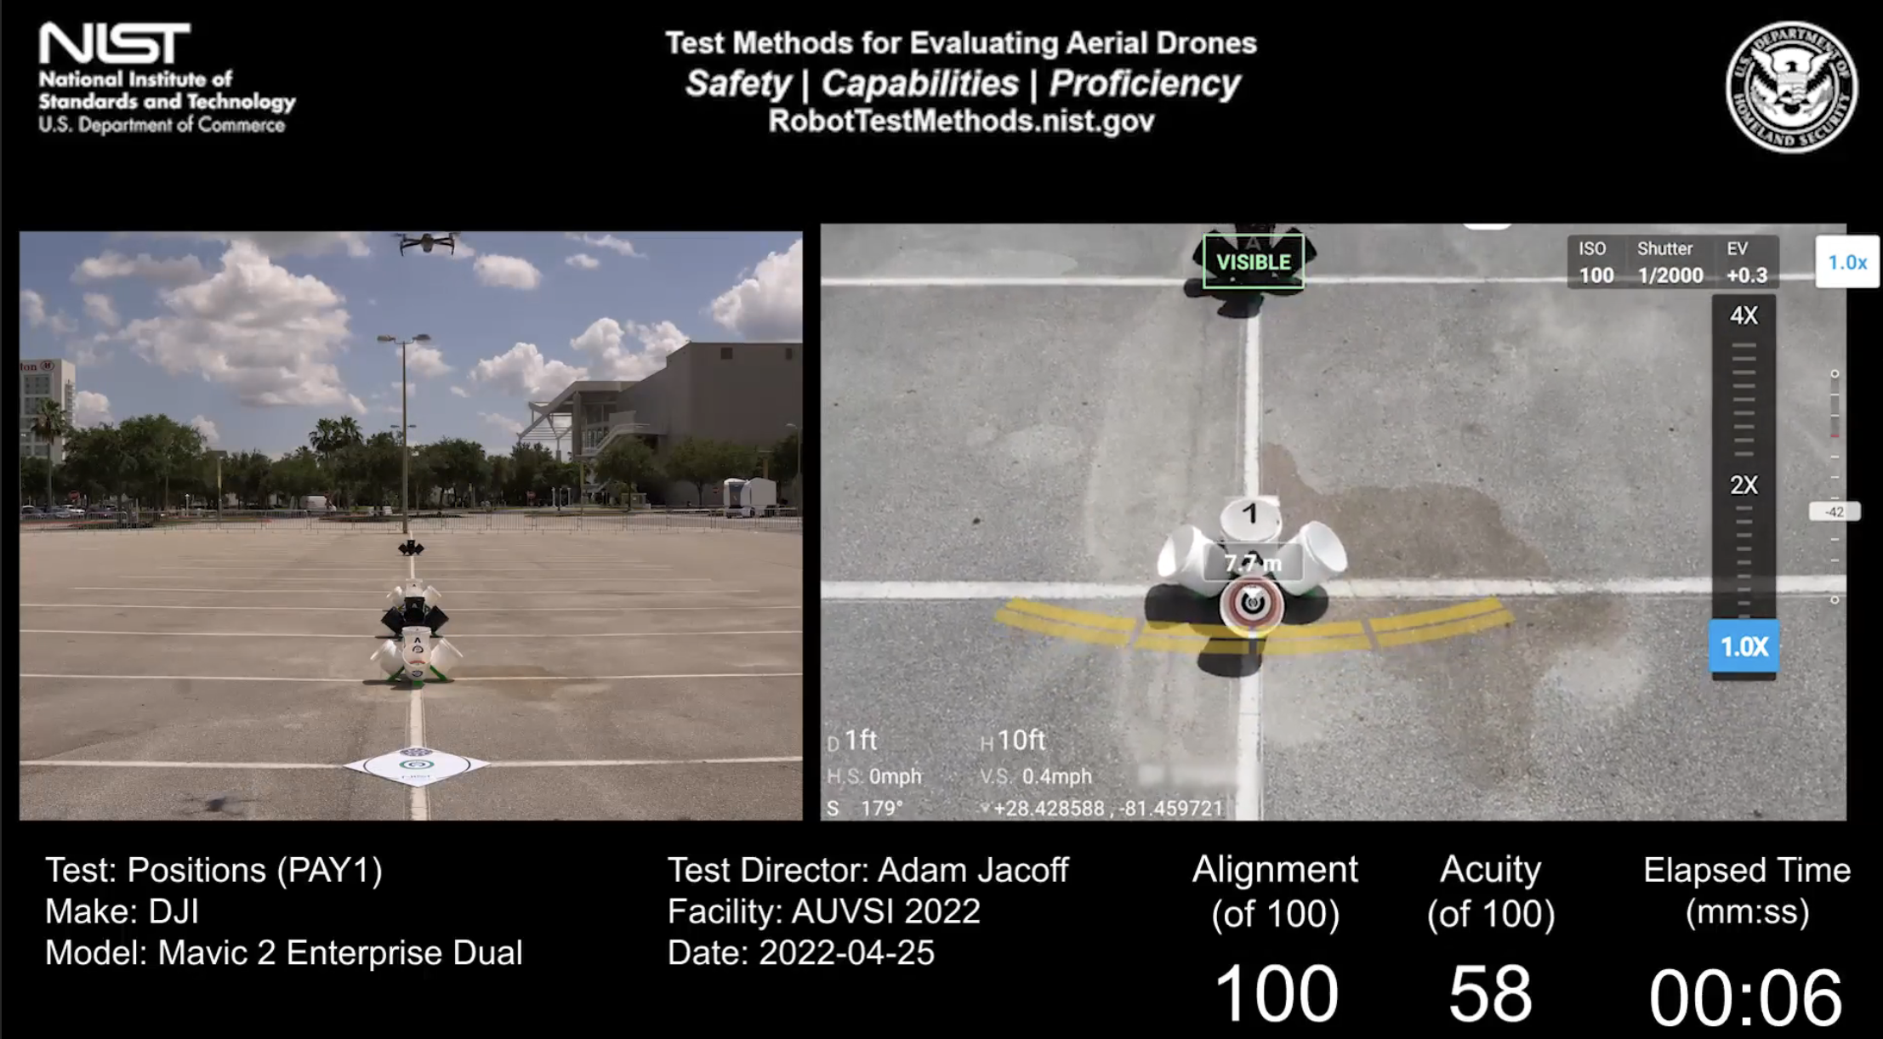
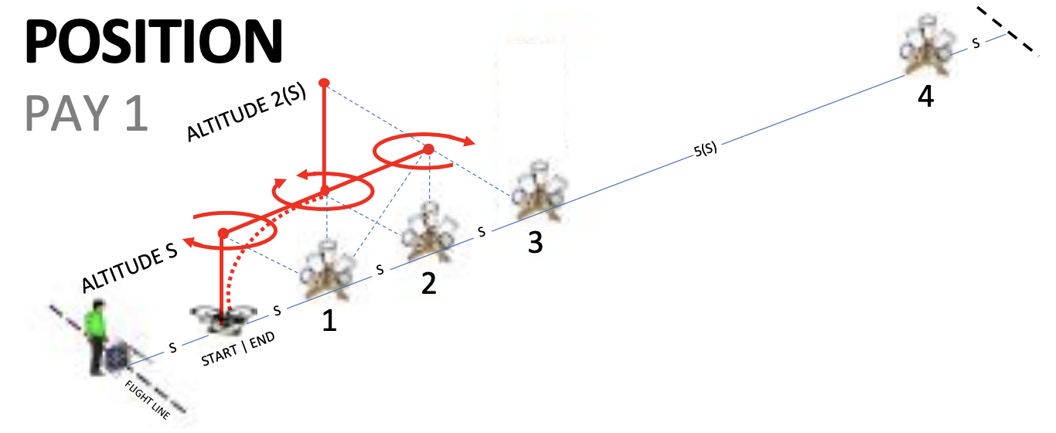

Simulating BVLOS:
After mastering the scenario, simulate BVLOS by having the pilot turn their back to the test range and rely on a visual observer for guidance. This practice will help develop the pilot's skills in managing the drone without direct visual contact, an essential capability for advanced operations.

Lesson Plan: TRAVERSE (MAN/PAY 2)
Introduction:
This lesson focuses on flying sideways while maintaining forward orientation, simulating scenarios such as inspecting buildings or wooded areas. Mastery of this maneuver enhances the pilot’s ability to perform detailed inspections and maintain control in complex environments.

Pre-Flight Briefing:
- Objectives: Complete laps around omni bucket stands, aligning with designated buckets.
  - Fly sideways parallel to objects while looking forward to identify features as if along a road, truck, bus, building, fence, tree line, etc.
  - Maintain altitude S flying leftward and rightward around the first three bucket stands to TAKE A PICTURE OF all the designated buckets.
  - Complete 1 lap leftward then 1 lap rightward with 18 alignments and 2 accurate landings to score up to 100 points.
- Safety Check: Ensure all safety protocols are in place and the drone is in optimal condition.
- Equipment: Verify camera functionality and adjust settings for clear image capture.
- Procedure:
TRAVERSE TEST – FLYING LEFTWARD
- HOVER OVER THE LAUNCH PLATFORM TAKE A PICTURE OF BUCKET 1A
- ORBIT 90° LEFTWARD AROUND STAND #1 TAKE A PICTURE OF BUCKET 1B
- ROLL LEFTWARD TO STAND #2 TAKE A PICTURE OF BUCKET 2B
- ROLL LEFTWARD TO STAND #3 TAKE A PICTURE OF BUCKET 3B
- ORBIT 90° LEFTWARD AROUND STAND #3 TAKE A PICTURE OF BUCKET 3C
- ORBIT 90° LEFTWARD AROUND STAND #3 TAKE A PICTURE OF BUCKET 3D
- ROLL LEFTWARD TO STAND #2 TAKE A PICTURE OF BUCKET 2D
- ROLL LEFTWARD TO STAND #1 TAKE A PICTURE OF BUCKET 1D
- ORBIT 90° LEFTWARD AROUND STAND #1 TAKE A PICTURE OF BUCKET 1A
- LAND IN CIRCLE (ONE OR MORE LEGS) – WORTH 1 POINT
TRAVERSE TEST – FLYING RIGHTWARD
- HOVER OVER THE LAUNCH PLATFORM TAKE A PICTURE OF BUCKET 1A
- ORBIT 90° RIGHTWARD AROUND STAND #1 TAKE A PICTURE OF BUCKET 1D
- ROLL RIGHTWARD TO STAND #2 TAKE A PICTURE OF BUCKET 2D
- ROLL RIGHTWARD TO STAND #3 TAKE A PICTURE OF BUCKET 3D
- ORBIT 90° RIGHTWARD AROUND STAND #3 TAKE A PICTURE OF BUCKET 3C
- ORBIT 90° RIGHTWARD AROUND STAND #3 TAKE A PICTURE OF BUCKET 3B
- ROLL RIGHTWARD TO STAND #2 TO ALIGN TAKE A PICTURE OF BUCKET 2B
- ROLL RIGHTWARD TO STAND #1 TO ALIGN TAKE A PICTURE OF BUCKET 1B
- ORBIT 90° RIGHTWARD AROUND STAND #1 TAKE A PICTURE OF BUCKET 1A
- LAND IN CIRCLE (ONE OR MORE LEGS ) – WORTH 1 POINT
https://drive.google.com/file/d/1Jl0BhOUhIJa4pmWPh0Z8ZCQdHAAS6CxW/view?usp=sharing
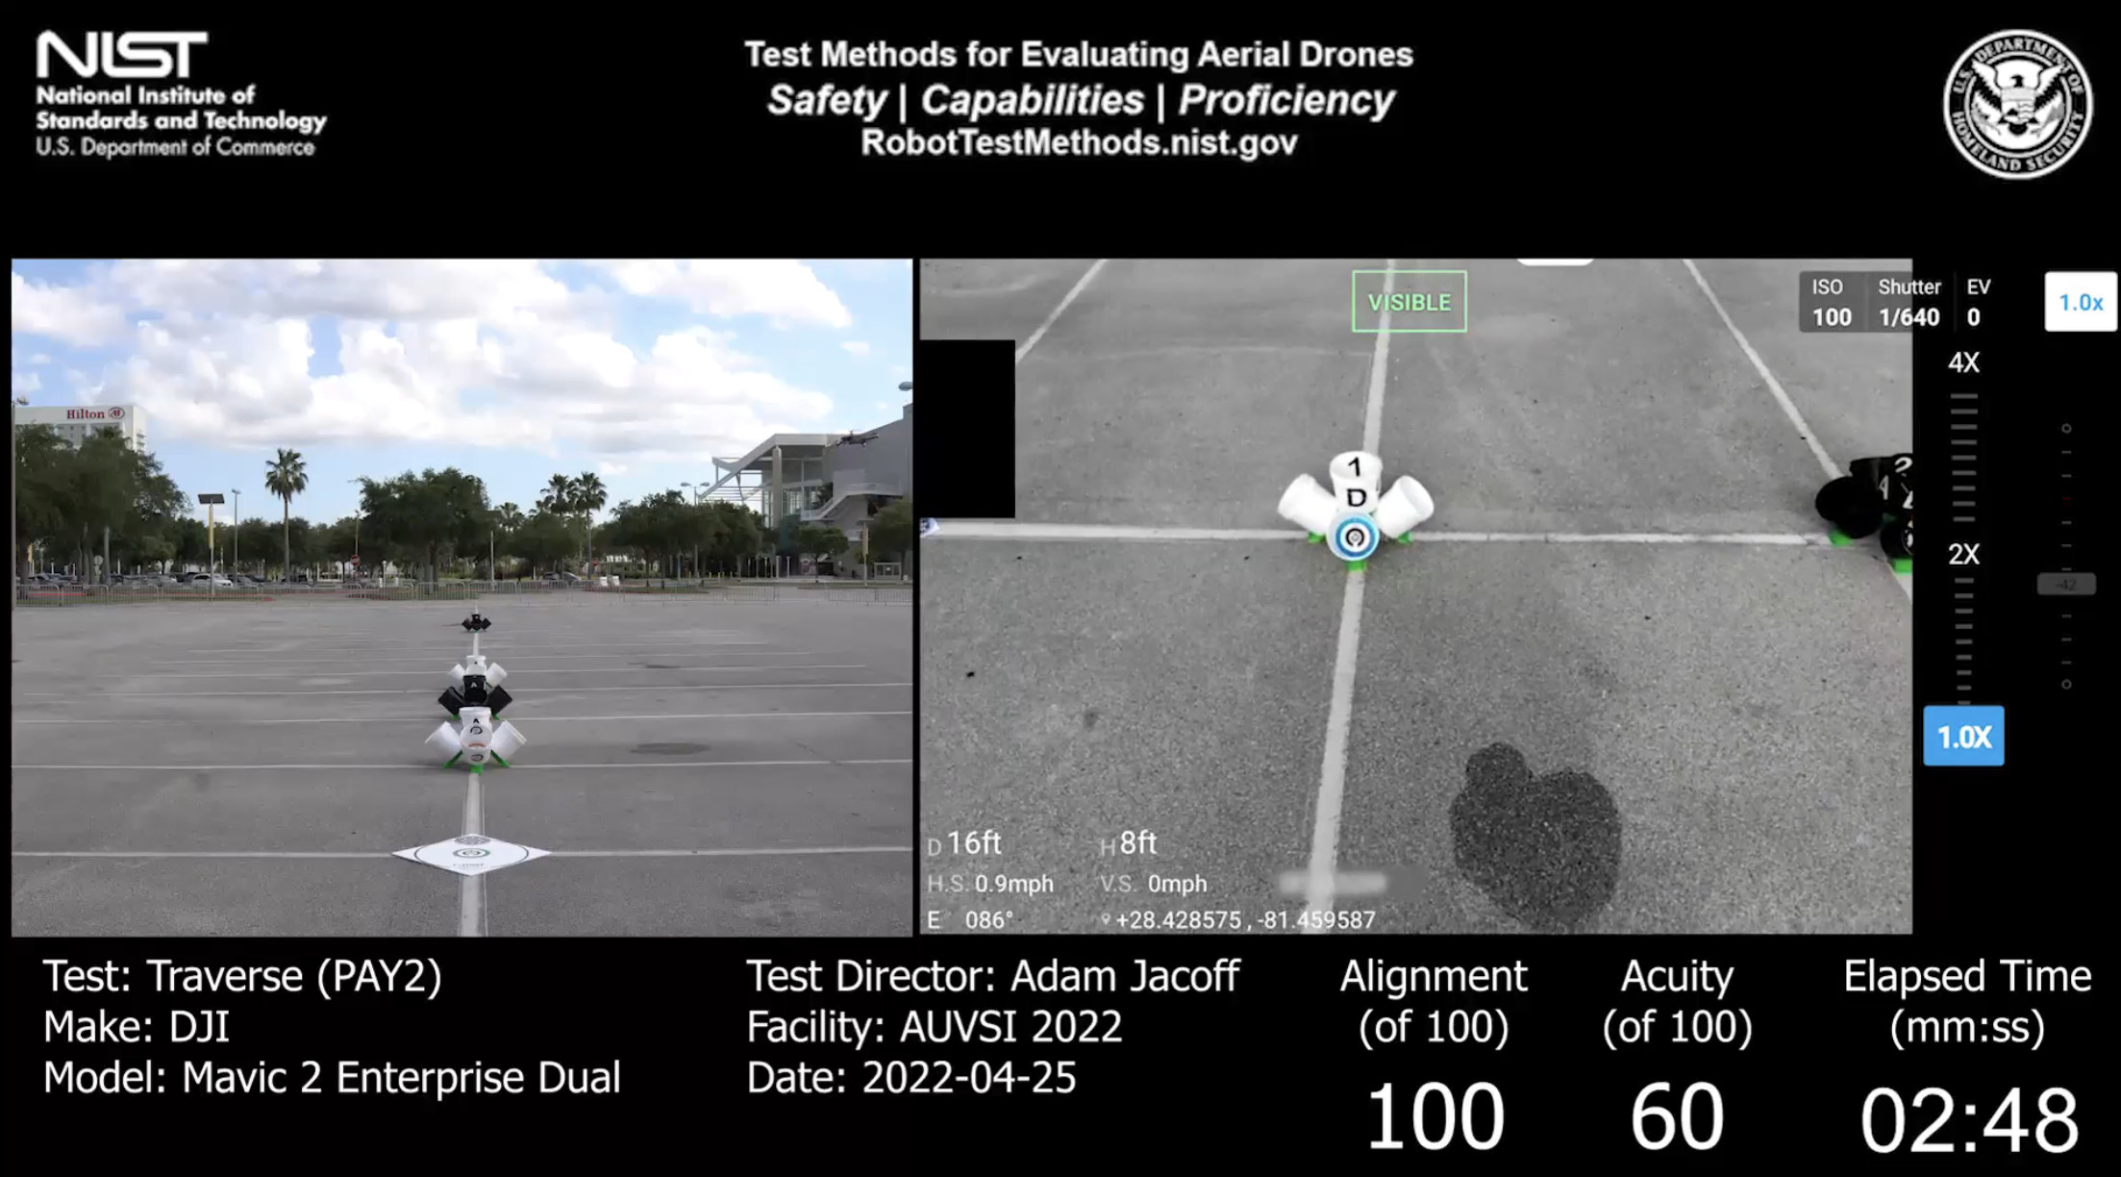

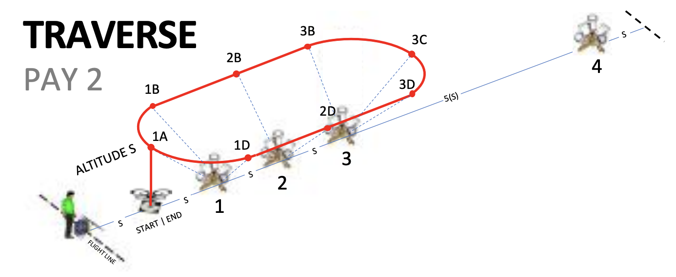
Simulating BVLOS:
Upon mastering this scenario, implement BVLOS simulation by using a visual observer. The pilot should turn away from the test range and rely on the observer for guidance, enhancing their proficiency in non-line-of-sight operations.

Lesson Plan: ORBIT (MAN/PAY 3)
Introduction:
The orbit maneuver requires flying circular paths around objects, looking inward to inspect features from all angles. This skill is vital for tasks requiring detailed inspection of structures and environments.

Pre-Flight Briefing:
- Objectives: Fly orbits around bucket stands, capturing images of inscribed rings and identifying targets.
  - Fly circular orbits around designated bucket stands while looking inward to identify features on all four sides. Fly altitude 2(S) leftward and rightward around stand #3, then altitude S leftward and rightward around stand #2.
  - Each orbit has 5 bucket alignments starting with 1 downward radius check then 4 altitude checks around the orbit looking inward at the angled buckets.
  - Complete 4 orbits with 20 alignments to score up to 100 points.
- Safety Check: Confirm all safety measures are in place and the drone is flight-ready.
- Equipment: Ensure the camera is set for optimal performance.
- Procedure:
- ALIGN OVER STAND #1 AT ALT 2(S) CHECK RADIUS TAKE PICTURE OF BUCKET 1
- ALIGN WITH BUCKET 3A CHECK ALTITUDE TAKE PICTURE OF BUCKET 3A
- ORBIT LEFTWARD 90° TAKE PICTURE OF BUCKET 3B
- ORBIT LEFTWARD 90° TAKE PICTURE OF BUCKEY 3C
- ORBIT LEFTWARD 90°TAKE PICTURE OF BUCKET 3D
- ALIGN OVER STAND #1 AT ALT 2(S) CHECK RADIUS TAKE PICTURE OF BUCKET 1
- ALIGN WITH BUCKET 3A CHECK ALTITUDE TAKE PICTURE OF BUCKET 3A
- ORBIT RIGHTWARD 90° TAKE PICTURE OF BUCKET 3D
- ORBIT RIGHTWARD 90° TAKE PICTURE OF BUCKET 3C
- TAKE PICTURE OF BUCKET 3B
- ORBIT RIGHTWARD 90° DESCENT TO (S) TAKE PICTURE OF BUCKET 1
- ALIGN OVER STAND #1 AT ALT S CHECK RADIUS TAKE PICTURE OF BUCKET 2A
- ALIGN WITH BUCKET 2A CHECK ALTITUDE TAKE PICTURE OF BUCKET 2B
- ORBIT LEFTWARD 90° TAKE PICTURE OF BUCKET 2C
- ORBIT LEFTWARD 90° TAKE PICTURE OF BUCKET 2D
- ALIGN OVER STAND #1 AT ALT S CHECK RADIUS 90° TAKE PICTURE OF BUCKET 1
- ALIGN WITH BUCKET 2A CHECK ALTITUDE TAKE PICTURE OF BUCKET 2A
- ORBIT RIGHTWARD 90° TAKE PICTURE OF BUCKET 2D
- ORBIT RIGHTWARD 90° TAKE PICTURE OF BUCKET 2C
- ORBIT RIGHTWARD 90° TAKE PICTURE OF BUCKET 2B

https://drive.google.com/file/d/1fKL2RiVQxjSheZDJqLeU05X3azWsaHF8/view?usp=sharing
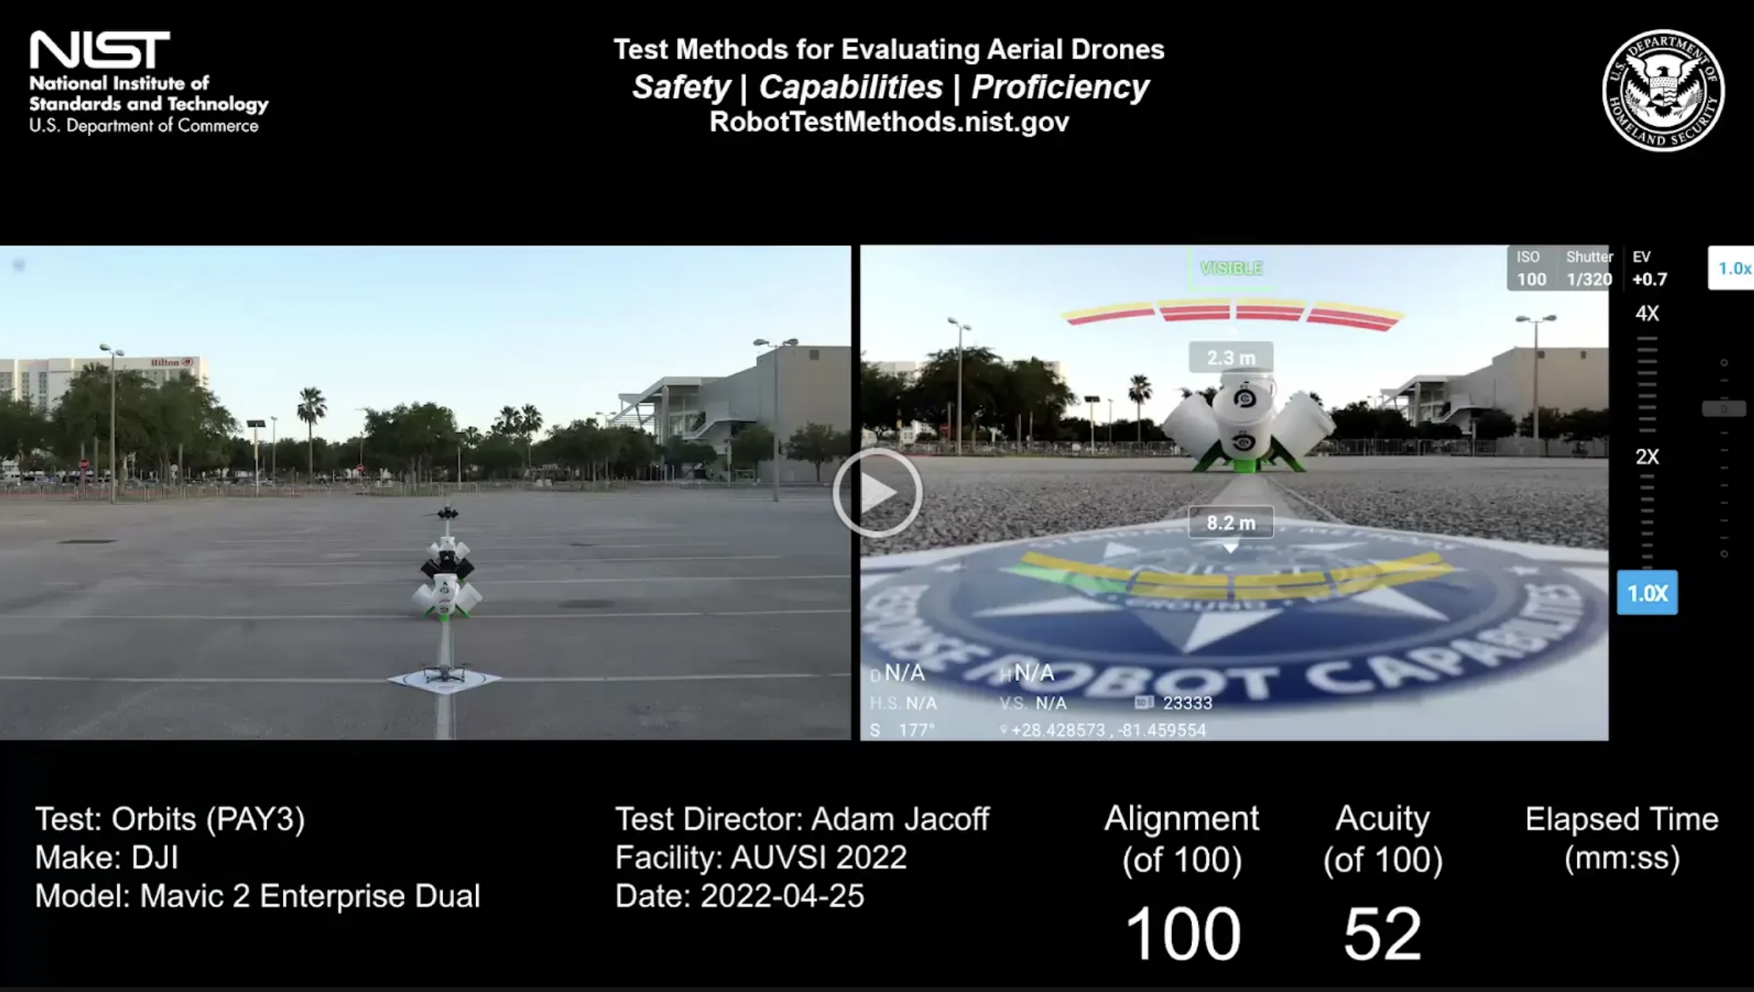

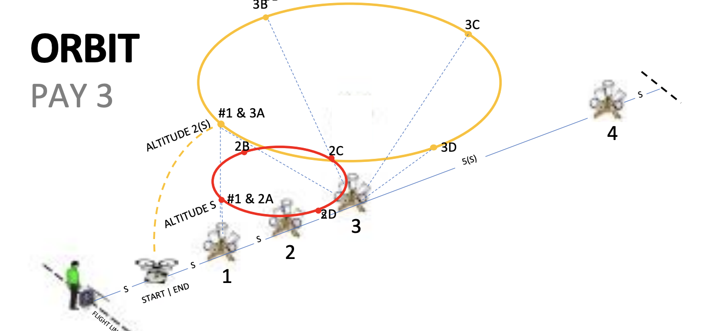
Simulating BVLOS:
Simulate BVLOS after mastering the maneuver by having the pilot face away from the test range, relying on a visual observer. This practice will improve their ability to control the drone without direct visual contact.

Lesson Plan: INSPECT (MAN/PAY 4)
Introduction:
This lesson focuses on close proximity inspection, evaluating the pilot’s ability to maneuver around objects and inspect detailed features. This skill is essential for tasks such as infrastructure inspection and search-and-rescue operations.

Pre-Flight Briefing:
- Objectives: Perform detailed inspections around bucket stands at close proximity.
  - Fly in closer proximity around objects to inspect detailed features on top and all four sides of the bucket stands.
  - Maintain altitude 1/2(S) starting on top of each bucket stand with alternating leftward and rightward rotations to inspect all four sides of each bucket stand.
  - Complete all 4 stands with 20 alignments to score up to 100 points.
- Safety Check: Ensure all safety protocols are followed and the drone is in optimal condition.
- Equipment: Adjust the camera for detailed inspection tasks.
- Procedure:
- HOVER OVER STAND #1 AT ALTITUDE 1/2(S) TAKE BICTURE OF BUCKET 1
- PITCH BACKWARD TAKE BICTURE OF BUCKET 1A
- ORBIT LEFTWARD 90° TAKE BICTURE OF BUCKET 1B
- ORBIT LEFTWARD 90° TAKE BICTURE OF BUCKET 1C
- ORBIT LEFTWARD 90° TAKE BICTURE OF BUCKET 1D
- HOVER OVER STAND #2 AT ALTITUDE 1/2(S) TAKE BICTURE OF BUCKET 2
- PITCH BACKWARD TAKE BICTURE OF BUCKET 2A
- ORBIT RIGHTWARD 90° TAKE BICTURE OF BUCKET 2D
- ORBIT RIGHTWARD 90° TAKE BICTURE OF BUCKET 2C
- ORBIT RIGHTWARD 90° TAKE BICTURE OF BUCKET 2B
- HOVER OVER STAND #3 AT ALTITUDE 1/2(S) TAKE BICTURE OF BUCKET 3
- PITCH BACKWARD TAKE BICTURE OF BUCKET 3A
- ORBIT LEFTWARD 90° TAKE BICTURE OF BUCKET 3B
- ORBIT LEFTWARD 90° TAKE BICTURE OF BUCKET 3C
- ORBIT LEFTWARD 90° TAKE BICTURE OF BUCKET 3D
- HOVER OVER STAND #4 AT ALTITUDE 1/2(S) TAKE BICTURE OF BUCKET 4
- PITCH BACKWARD TAKE BICTURE OF BUCKET 4A
- ORBIT RIGHTWARD 90° TAKE BICTURE OF BUCKET 4D
- ORBIT RIGHTWARD 90° TAKE BICTURE OF BUCKET 4C
- ORBIT RIGHTWARD 90° TAKE BICTURE OF BUCKET 4B

https://drive.google.com/file/d/1x26hT0w-9s-msVhJpogtjUvZAIeDkTnU/view?usp=sharing
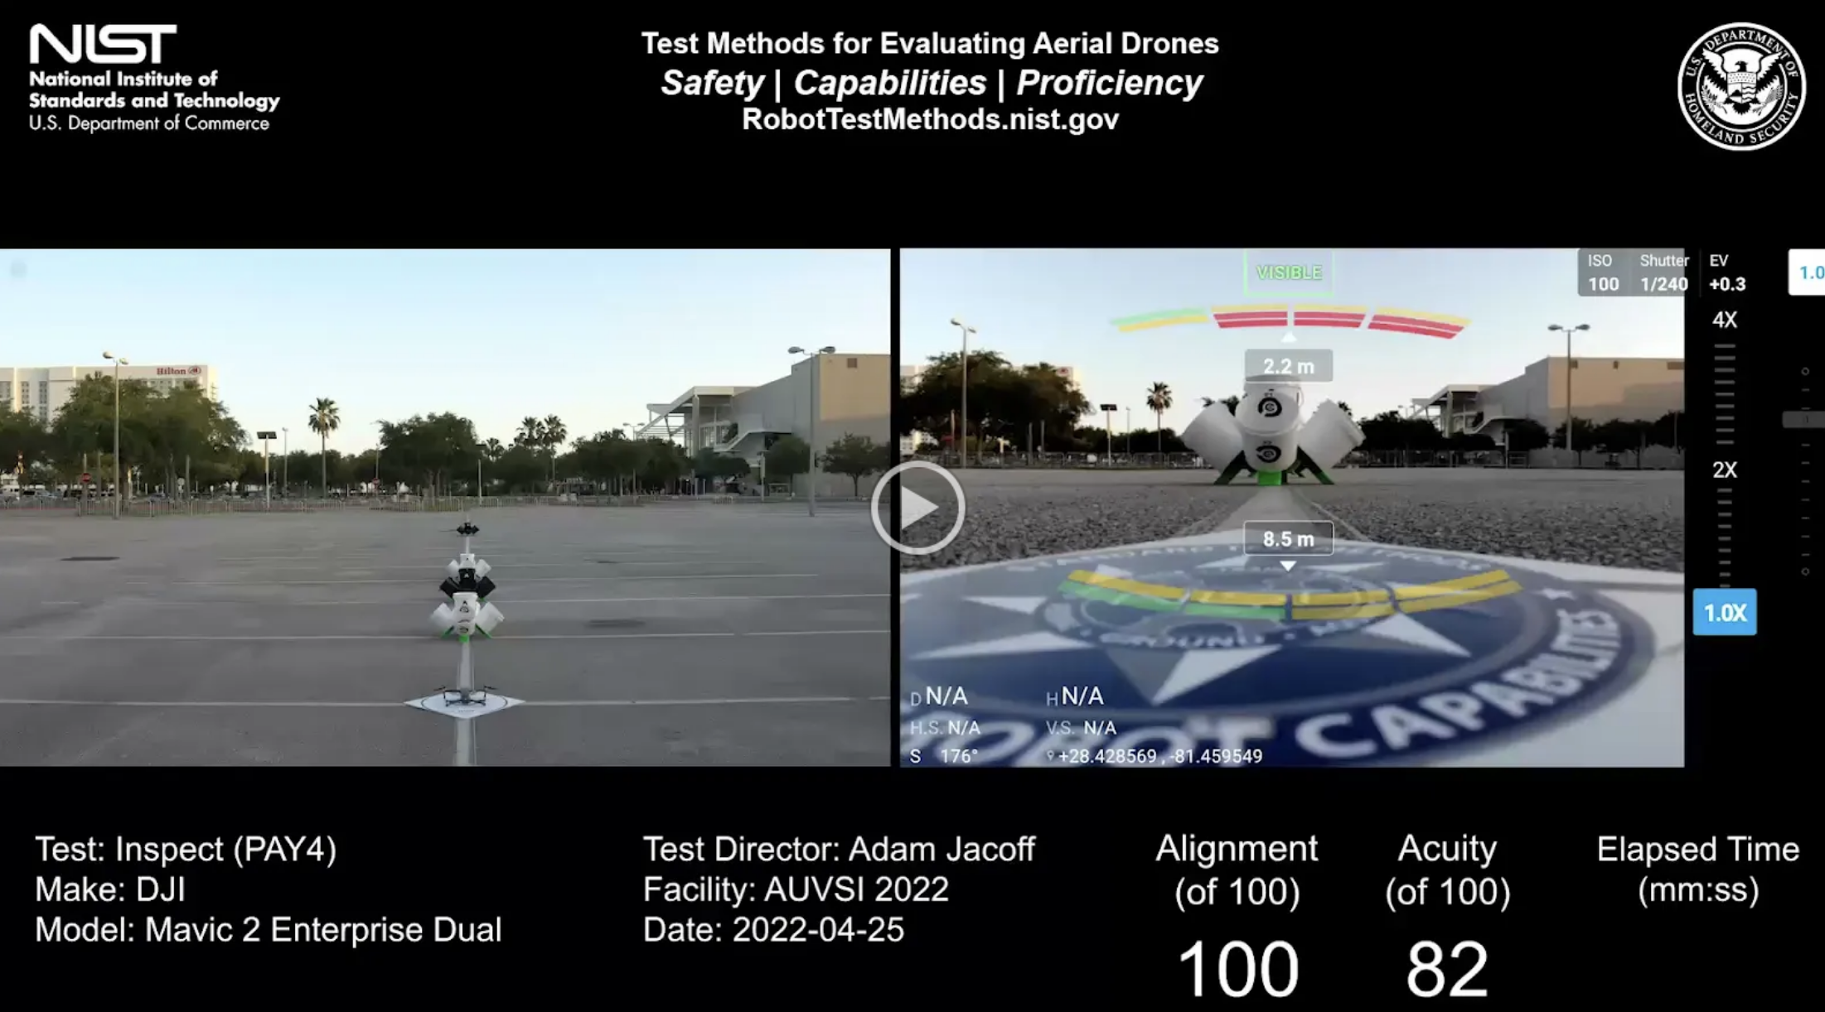
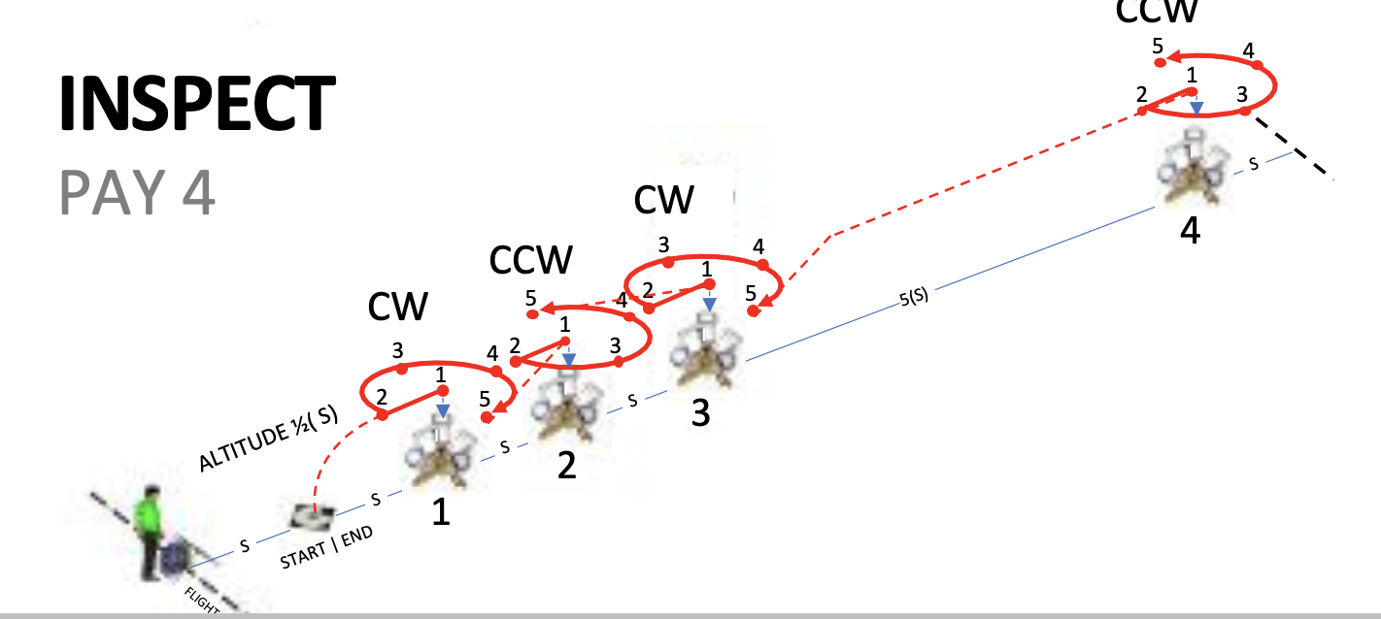
Simulating BVLOS:
Enhance proficiency by simulating BVLOS operations. Have the pilot turn their back to the test range and rely on a visual observer for guidance, improving their skills in managing the drone without direct visual contact.

Lesson Plan: RECON (MAN/PAY 5)
Introduction:
This lesson involves flying straight and level over a lane to perform reconnaissance tasks. Mastering this maneuver is crucial for surveillance and reconnaissance missions, ensuring stable flight and accurate data collection.

Pre-Flight Briefing:
Objectives: Establish stable hovers and perform reconnaissance tasks over designated objects.
  - Fly straight and level over the centerline to establish a stable hover over an object down range to perform reconnaissance tasks.
  - Maintain altitude S to TAKE A PICTURE OF buckets and the landing at each end of the lane. Reconnaissance tasks are performed every 8(S) over a total distance of 80(S).
  - Complete 5 laps (or 10 lane lengths) with 20 alignments to score up to 100 points.
Safety Check: Follow all safety protocols and ensure the drone is ready for flight.
Equipment: Set the camera for optimal performance.
Procedure:
- FLY AT ALTITUDE S TO STAND #4 TAKE A PICTURE OF BUCKET 4
- YAW LEFT 180° TAKE A PICTURE OF BUCKET 4
- FLY TO THE LAUNCH AND YAW RIGHT 180° TAKE A PICTURE OF LAUNCH PAD
- HOVER IN PLACE CHECK ALTITUDE S TAKE A PICTURE OF BUCKET 1A
- FLY AT ALTITUDE S TO STAND #4 TAKE A PICTURE OF BUCKET 4
- YAW LEFT 180° TAKE A PICTURE OF BUCKET 4
- FLY TO THE LAUNCH AND YAW RIGHT 180°TAKE A PICTURE OF LAUNCH PAD
- HOVER IN PLACE CHECK ALTITUDE S TAKE A PICTURE OF BUCKET 1A
- FLY AT ALTITUDE S TO STAND #4 TAKE A PICTURE OF BUCKET 4
- YAW LEFT 180° TAKE A PICTURE OF BUCKET 4
- FLY TO THE LAUNCH AND YAW RIGHT 180° TAKE A PICTURE OF LAUNCH PAD
- HOVER IN PLACE CHECK ALTITUDE S TAKE A PICTURE OF BUCKET 1A
- FLY AT ALTITUDE S TO STAND #4 TAKE A PICTURE OF BUCKET 4
- YAW LEFT 180°TAKE A PICTURE OF BUCKET 4
- FLY TO THE LAUNCH AND YAW RIGHT 180° TAKE A PICTURE OF LAUNCH PAD
- HOVER IN PLACE CHECK ALTITUDE S TAKE A PICTURE OF BUCKET 1A
- FLY AT ALTITUDE S TO STAND #4 TAKE A PICTURE OF BUCKET 4
- YAW LEFT 180° TAKE A PICTURE OF BUCKET 4
- FLY TO THE LAUNCH AND YAW RIGHT 180° TAKE A PICTURE OF LAUNCH PAD
- HOVER IN PLACE CHECK ALTITUDE S TAKE A PICTURE OF BUCKET 1A
https://drive.google.com/file/d/1grYQ2jqb3Ar9xGz9nqlwzGwGRDkFHig5/view?usp=sharing
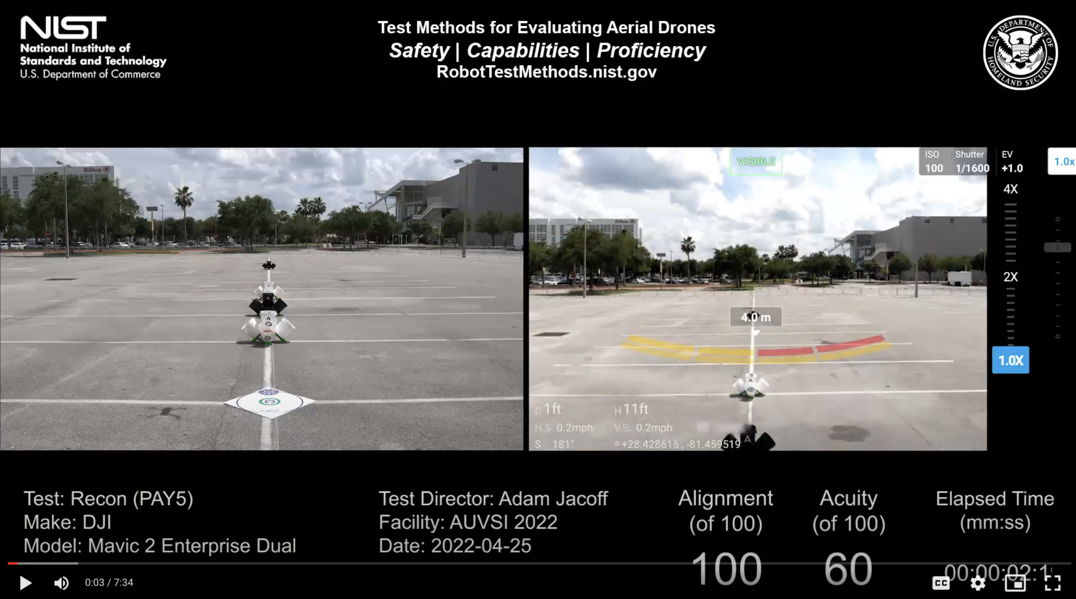
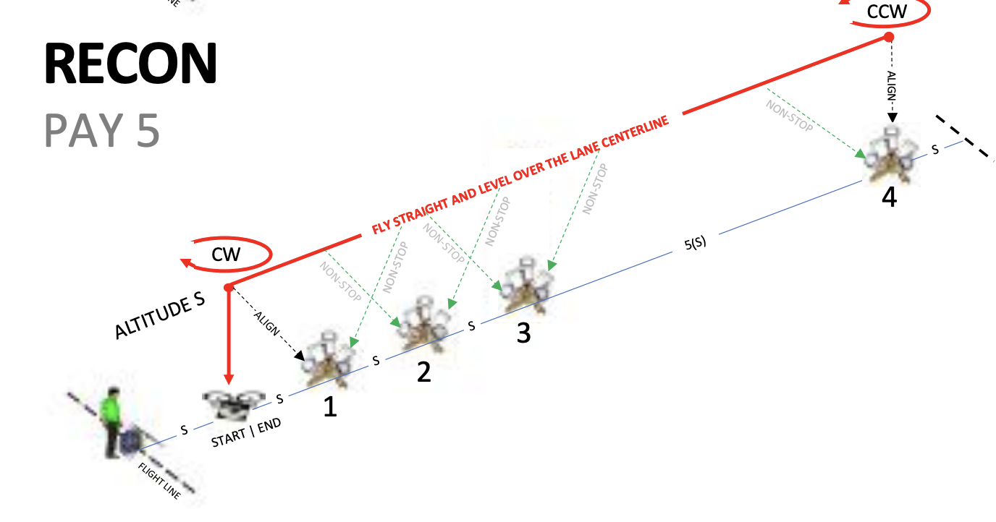

Simulating BVLOS: After mastering the scenario, practice BVLOS by using a visual observer while the pilot faces away from the test range. This will develop their ability to control the drone and perform tasks without direct visual contact, crucial for advanced operations.

